Examples of visual poetry, as reference:
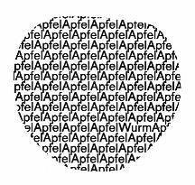 | 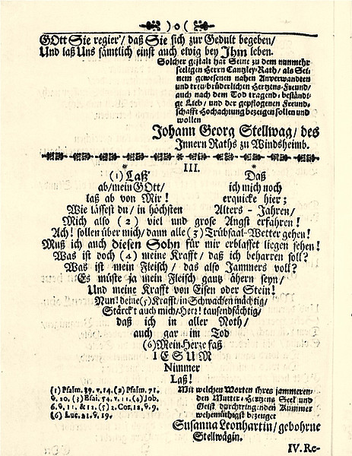
Rainer Döhl, Apfel | https://www.wlb-stuttgart.de/sammlungen/alte-und-wertvolle-drucke/bestand/familienpredigten/diverse-2/
wolke wolke
wolkewolkewolkewolke
wolkewolkewolkewolke
wolkewolkewolkewolke
wolke wolke
B B
L Lb
I I l t z
T T i
Z Z tz
Christian Morgensterns Fisches Nachtgesang
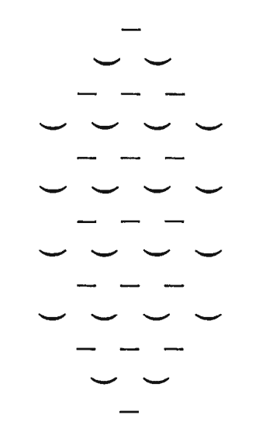
Caroline Bergvall:
B) I would ask all to look at this piece rock/wave by the concrete poet and sculptor Ian Hamilton Finlay and start writing a short critical piece (roughly 0,5-1 page):
1) identify the limits of the poem
2) what is the reader/viewer’s perception of the piece, here in 2 different settings/publishings (https://visual-poetry.tumblr.com/post/141658463725/waverock-by-ian-hamilton-finlay and attached)
My first question is, how we, today, in 2021, understand a piece of concrete poetry, or visual poetry. Does it have more than historical interest? Do we need to focus on the limitations of this form of art, or can we also see its potential for further development, as visible in Caroline Bergvall’s own work?
Before we can set out to answer these questions, it would be useful to first describe the object under consideration. Finlay’s “rock/wave” is a work that comes in may different iterations, as I found by searching for it on the web, see power point. We were asked to write about a later version in which a word structure is complemented by a photograph of what the words say and depict: a rock in form of a wave, a wave like a rock. The words are in or on a glass plane and set on the photo or painting. The size of the wave depicted by the words are about the same size as the photographed rock or mountain.
In this image, then, we have three iterations of the same meaning or signifier: 1) words signifying a rock that looks like a wave, 2) words that are printed repeatedly and arranged so that they look like a wave, seen from the side, cut through, or in a glass box as they can be seen in science museums, and 3) a photo of a rock that looks like a wave. Thus, the work invites us to reflect on how media present the same idea differently, and how our idea of that wave/rock is influenced by the media. The different forms do not necessarily present the same idea; thus we can reflect on how a medial representation can change the meaning of words. For instance the words wave/rock in the shape of a wave do not need to lead to the imagination of a rock in shape of a wave. They remain open; they could refer to a wave breaking on a rock, or a rock looking like a wave, or a rock under a wave. The photo fixes those possible meanings. The copy of the image posted by Anatol Knotek is in black and white. This image focuses the meaning of “wave/rock” on the wave, as it shows only calm waters, a like and now wave of the same height as that of the words, overlaid with the same glass pane containing the words “wave” and “rock.”
What we can learn and still appreciate in wave/rock is, I believe, the awareness that it raises of the limits of our perception and understanding, and how our visual imagination is related to the meaning we ascribe to words.

